H.T No
Regulations:
A22

Sreenidhi Institute of Science and Technology
(An Autonomous Institution)
Code No: 9BC01 Date:15-Spet-2023 (FN)

B.Tech I-Year I- Semester External Examination, September-2023 (Supplementary)
ENGINEERING GRAPHICS (CIVIL, EEE, ME, ECE and ECM)

Time: 3 Hours Max.Marks:60

Note: a) No additional answer sheets will be provided.
b) All sub-parts of a question must be answered at one place only, otherwise it will not be valued.
c) Missing data can be assumed suitably.
Bloom's Cognitive Levels of Learning (BCLL)

Remember | L1 | Apply | L3 | Evaluate | L5
Understand | L2 | Analyze | L4 | Create | L6

Part - A Max.Marks: 6x2=12

Answer all QUESTIONS, EACH QUESTION CARRIES 2 MARKS.

 |  | BCLL | CO(s) | Marks
1 | Define Parabola. | L1 | CO1 | [2M]
2 | What is meant by Projection? | L1 | CO2 | [2M]
3 | Name the two Principal Planes of Projection. | L1 | CO3 | [2M]
4 | Define section Plane. | L1 | CO4 | [2M]
5 | Name the solids of Revolution. | L1 | CO5 | [2M]
6 | Give the practical applications hyperbola. | L1 | CO6 | [2M]

Part – B Max.Marks: 6x8=48
ANSWER ALL QUESTIONS. EACH QUESTION CARRIES 8 MARKS.

 |  |  | BCLL | CO(s) | Marks
7. | a) | Construct an ellipse when the distance between the focus and the directrix is 35 mm and the eccentricity is ¾. | L3 | CO1 | [8M]
 |  | OR
 | b) | Construct a parabola when the distance between focus and the directrix is 40mm. | L3 | CO1 | [8M]
8. | a) | Draw the projections of the following point,  i) Point A, 25mm above the H.P. and 30mm in front of the V.P.  ii) Point B, 30mm below the H.P. and 30mm behind the V.P.  iii) Point C, 45mm above the H.P. and 35mm behind the V.P.  iv) Point D, 20mm below the H.P. and 20mm in front of the V.P. | L1 | CO2 | [8M]
 |  | OR
 | b) | A line AB 80mm long has its end A 20mm above HP and 25mm in front of VP.The line is inclined a 45º to HP and 35º to VP.Draw its projections. | L1 | CO2 | [8M]
9. | a) | A pentagonal plate of 45 mm side rests on one of its sides on the HP with its plane perpendicular to VP and 45⁰ inclined to the HP. Draw the projections. | L1 | CO3 | [8M]
 |  | OR
 | b) | Draw the projections of(i) a cylinder, base 50 mm diameter and axis 75 mm long resting on the HP on their respective bases. | L1 | CO3 | [8M]
10. | a) | A cone with diameter of base 50 mm and axis 60 mm long, is resting on its base on HP. It is cut by a section plane, inclined at 45⁰ to HP and passing through the axis at a point 35 mm above HP. Draw the projections of the cut solid. | L1 | CO4 | [8M]
 |  | OR
 | b) | A hexagonal prism of base side 30mm and height 60mm rests vertically on HP with a side of base parallel to VP. Draw the development of the surfaces of the prism. | L1 | CO4 | [8M]
11. | a) | A cylinder of base 60mm diameter and height 90mm is standing on HP. With is axis perpendicular to HP. Draw its Isometric view. | L1 | CO5 | [8M]
 |  | OR
 | b) | Draw the isometric view of a hexagonal pyramid of side of base 30 mm and height 75 mm, when it is resting on HP such that an edge of the base is parallel to VP. | L1 | CO5 | [8M]
12. | a) | Draw front view ,top view and side views of the of the isometric view shown in fig.  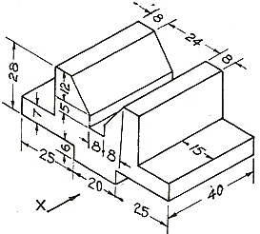 | L1 | CO6 | [8M]
 |  | OR
 | b) | Draw front view ,top view and side views of the of the isometric view shown in fig.  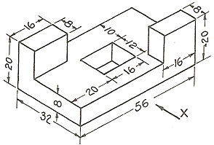 | L1 | CO6 | [8M]

-- 00 -- 00 –

